LICHEN FIELD GUIDE 1
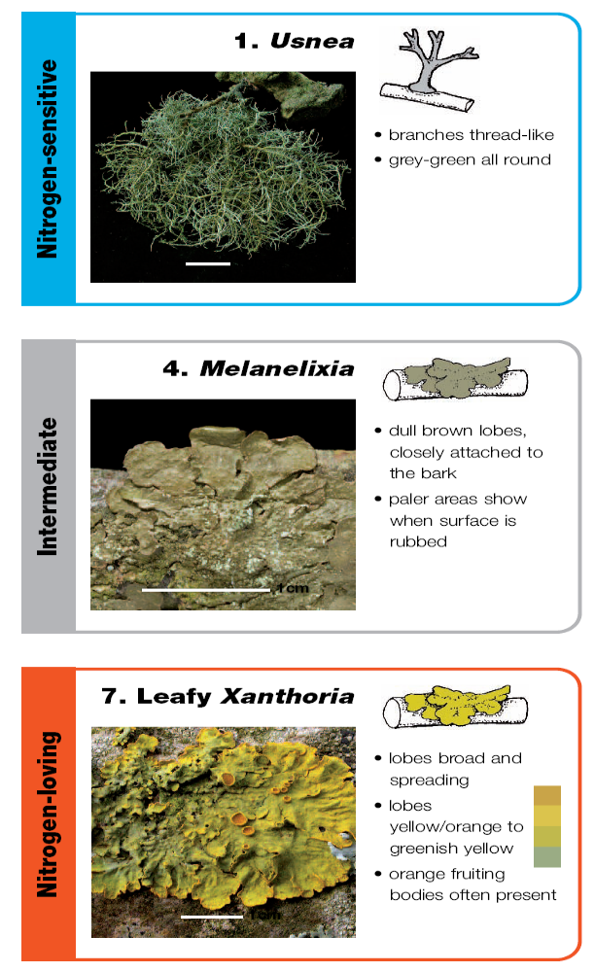
LICHEN FIELD GUIDE 2
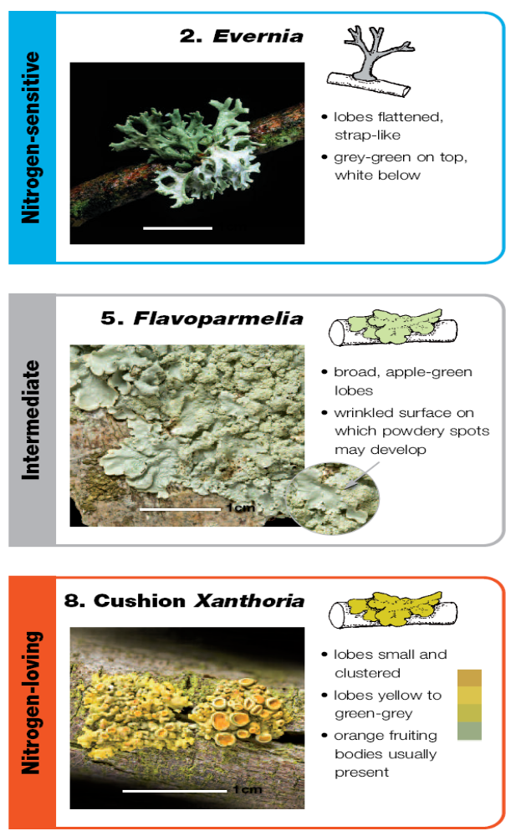
LICHEN FIELD GUIDE 3


