**GEOG 1301 UNIT 8 REVIEW**

**EARTH SYSTEM SCIENCE ANALYSIS**

Earth System Science analysis, or ESS analysis, examines each event to sphere, sphere to event and sphere to sphere interaction.

An ESS analysis has four steps, which include looking at

* how the event affects each of the spheres,
* how each sphere affects the event,
* how the spheres affect each other, and
* connecting the interactions.

Step 1: Event > Sphere Interactions

How could an event affect each sphere? The answers to this question are the event > sphere impacts.

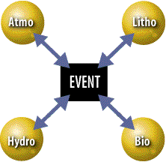

Step 2: Sphere > Event Interactions

How could each sphere affect the event? The answers to this question are the sphere > event impacts.

Step 3: Sphere > Sphere Interactions

How can each sphere affect the other spheres? The answers to this question are the sphere > sphere impacts.

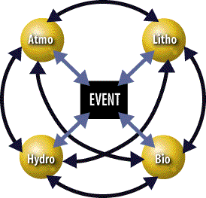

Step 4: Causal Chains

The interactions that occur within Earth's system actually occur as a series of chain reactions, which ripple through Earth's spheres like waves that spread out from a pebble tossed in a still pond. This means that an event often leads to a change in one sphere, which leads to a change in another sphere, which leads to a change in yet another sphere.