**GEOG 1301 UNIT 7 REVIEW**

**1. SOIL**

factors of soil formation

* climate
* organisms
* relief
* parent material

# time

Soil Horizons

* **O horizon** - The top layer of soil composed primarily of organic material, such as the litter of leaves and plants, insects and microorganisms.
* **A horizon** - Also known as the topsoil, where seeds germinate and plants' roots thrive.
* **E horizon** - Composed of sand and silt. Minerals and clay have been removed in a process known as eluviation.
* **B horizon** - Also known as the subsoil, this layer contains mineral deposits that have settled down from upper layers.
* **C horizon** - This layer is called the regolith and consists of rocks and little organic material (even roots don't penetrate this layer).
* **R horizon** - The "R" in R horizon stands for rock and it refers to the unconsolidated rock or solid bedrock of this layer.

Soil horizons form because of four development processes:

* **addition** – material added to the soil by wind, rain, decomposition and etc.
* **transformation** – changes in materials added to soil from chemical and biological processes
* **translocation** – the movement of material throughout the soil by water, animals and etc.
* **removal** – removal of materials from the soil

All the horizons taken together comprise the **soil profile**.

The properties of a soil are determined by the process under which they form. Though all soils are created by the processes of addition, transformation, translocation and removal, it is the soil forming or, **pedogenic processes**, that determine the kind of soil that is ultimately formed.

**Laterization** produces the deep red to bright orange-red soils of the tropics.

**Calcification** - occurring in warm, semi-arid environments, usually under grassland vegetation – produces soil rich in organic matter.

**Podzolization** occurs in cool and moist climates under pine forests and produces soil heavily leached and basically composed of a light colored layer of sand.

**Salinization** produces the saline soils that are common in desert and steppe climates.

**Gleization** occurs in waterlogged regions producing soil in which dead vegetation has accumulated in thick layers.

Finally, there are [twelve key **orders of soil**](http://soils.ag.uidaho.edu/soilorders/) in soil taxonomy. Most common around the world are Aridisols (desert soils), Inceptisols (weakly developed, infertile soil) and Alfisols (reasonably fertile clayish soils). Mollisols (humus-rich) are best for agriculture and occupy approximately one quarter of the US. (See Soil Taxonomy at<http://soils.ag.uidaho.edu/soilorders/>.)

**2. EARTH’S STRUCTURE**

The outer brittle shell of the earth is the **crust**. The crust is broken into several continental and oceanic **tectonic plates**. These plates ride atop the more pliable mantle beneath. The **mantle** makes up 80% of the Earth's total volume. It is mainly composed of a dark, dense rock called *peridotite* that is rich in iron and magnesium. The **core** is divided into the inner and outer cores. Though intense heat is generated at such great depths, geoscientists believe that under the enormous overlying pressure the inner core is made of solid iron and nickel. The outer core is thought to be molten iron and it is the interaction between the inner and outer core that produces Earth's magnetic field.

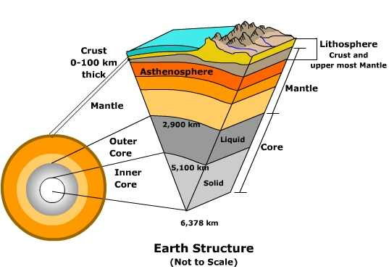

**3. INTERNAL PROCESSES**

Deep within the earth's core, the radioactive decay of elements like uranium, thorium and potassium generate heat. The heat transfers upward to warm the mantle causing it to slowly circulate and tug on the plates above. As the **tectonic plates** move, they interact by colliding (**collision**), sliding by or over one another (**subduction**) or moving away from one another (**divergence**). The result of such movement produces faults and earthquakes, volcanoes, the creation of mountain systems or deep valleys and trenches. The great mountain systems of earth like the Himalayas are a product of the collision of tectonic plates. Similarly, plate interaction causes the huge trenches found on the ocean floor, like the Marianas Trench.

**Plate Tectonic Theory**

* Plate - large crustal section of the earth’s surface
* Tectonic - movement of the earth
* Plate Tectonics - a unifying theory … explains the formation of continents, mountains, earthquakes, volcanoes … crust of the earth shifts 1-3 inches per year

**4. GEOMORPHOLOGY**

Geomorphology is the science of landforms with an emphasis on their origin, evolution, form and distribution across the physical landscape.

* built up landforms created by tectonic processes
* leveled landforms created by gradational processes – weathering, mass wasting, erosion, deposition

**Simple Model of Landform Development**

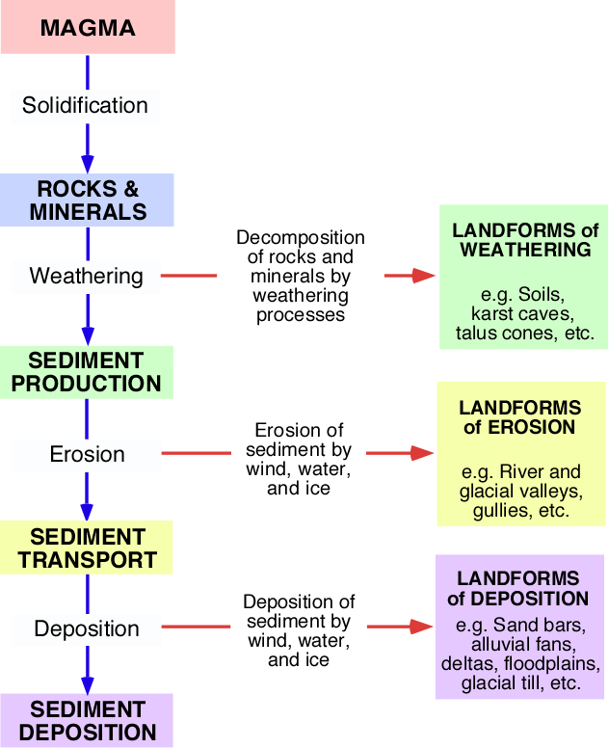

I. Weathering

weatheringprocesses

Chemical – hydrolysis**,** oxidation**,** reduction**,** hydration**,** carbonation**,** solution, decomposition

Physical/Mechanical – abrasion**,** crystallization**,** thermal insolation**,** wetting and drying**,** pressure release, frost, salt wedging, organic, unloading

weatheringproducts

regolith

soil

limestone landforms - karst, cave, spring, underground water channel, deposit from evaporation

**II. Erosion and Deposition**

erosion and deposition processes erosion and deposition products

plucking flocculation river valley sand bar

cavitation solution glacial valley alluvial fan

raindrop impact traction gully delta

abrasion saltation flood plain glacial till

entrainment suspension

**III. Hill Slope and Mass Movement**

hill slope and mass movement processes

rain splash stream channel rock slide

rain wash rotational slip solifluction

runoff slumping soil creep

sheet wash avalanche mudflow

[rill](http://www.physicalgeography.net/physgeoglos/r.html#anchor140172) rock fall landslide

Hill slope and mass movement products are self-evident.

**IV. Fluvial**

fluvial processes fluvial products

erosion fluid drag braided channel flood plain

deposition bank-caving meandering channel crevasse

stream discharge entrainment sand bar flood plain depression

flooding suspension gravel bar oxbow lake

point bar saltation point bar delta

meandering traction riffle alluvial fan

overbank flow, flooding aggradation scoured pool

**V. Coastal and Marine**

coastal and marine processes coastal and marine products

erosion beach drift beach spit

[sediment](http://www.physicalgeography.net/physgeoglos/s.html#anchor215347) [transport](http://www.physicalgeography.net/physgeoglos/t.html#anchor195185) rip current wave-cut notch bay head beach

wave action longshore current sea cliff barrier beach

friction longshore drift cave bay-mouth bar

deposition littoral drift sea arch tombolo

swash tidal current sea stack cuspate forelandbackwash

**VI. Glacial**

glacial processes

physical weathering basal sliding

pressure melting mass balance

abrasion mass movement - solifluction, gelifluction, frost creep, rock fall

melting evaporation

sublimation calving

scouring plucking

freeze-thaw process frost creep

insolation weathering erosion - nivation, eolian erosion and deposition, fluvial erosion and deposition

glacial products

glacial polish terminal moraine kettle hole

glacial milk recessional moraine pingo

roche mouton née drumlin palsa

hanging valley esker patterned ground

cirque lateral moraine sand sheet

cirque glacier kame loess

horn medial moraine sand dune

arête outwash deposit nivation hollow

talus glacial drift sand wedge

striation outwash plain ice wedge

glaciofluvial deposit closed talik through talik

till talik erratic

till plain

**VII. Eolian (Desert)**

eolian processes eolian products

erosion deflation hollow dune field

wind deposition pan wind ripple

traction desert pavement blowout

creep reg loess

saltation sand dune – barchan, transverse, parabolic, barchanoid ridge, longitudinal, seif, star dune, dome, reversing